ACADEMY OF TELEVISION ARTS & SCIENCES

2013 FOR YOUR CONSIDERATION (FYC) BY MAIL POLICIES AND PROCEDURES

Any entrant in the Primetime Emmy Awards competition may use the Television Academy's mailing house to send to the voting membership "For Your Consideration" (FYC) screeners.

To eliminate environmentally unfriendly mailings, all packaging must conform to the examples illustrated and described on page 2.

Non-conforming packaging will not be mailed by the Television Academy’s fulfillment house.

If you would like to post your Emmy-entered program(s) on the Television Academy’s FYC website, please refer to the separate “FYC online” document found at www.emmys.tv/downloads.

If you have entered the Emmy competition and would like to send a mailing, here is a summary of the "For Your Consideration" mailing policy and procedures:

In general, programs must be sent in their entirety – they may not be edited. However, if they wish, actors and actresses may edit to their appearances only. See “optional rule for performer entrants only” on page 3.

Content must be “as originally aired.” No title cards or slates. Please remove all bars and tones, countdown and commercial blacks. You may leave 1-2 seconds of black (if you’d like) to indicate the commercial breaks. You may include a menu if multiple programs or episodes are on one dvd.

FYC screeners will not be accepted with any additional marketing materials or elaborate packaging.

The printed material that is on the dvd or flash-drive sleeve, or on the box, may include branding and marketing information about the screeners.

No additional pages of solely written material. All pages must include a dvd or flash-drive.

If you create a box for your screeners to be mailed in as a self-mailer, rather than using a jiffy bag (supplied by the mailing house), you may not print your return address on it.

You may not use the image of the Emmy® statue.

No postcards may be sent.

Please contact Sheri Ebner (818) 754-2881 or ebner@emmys.org if you have any questions.
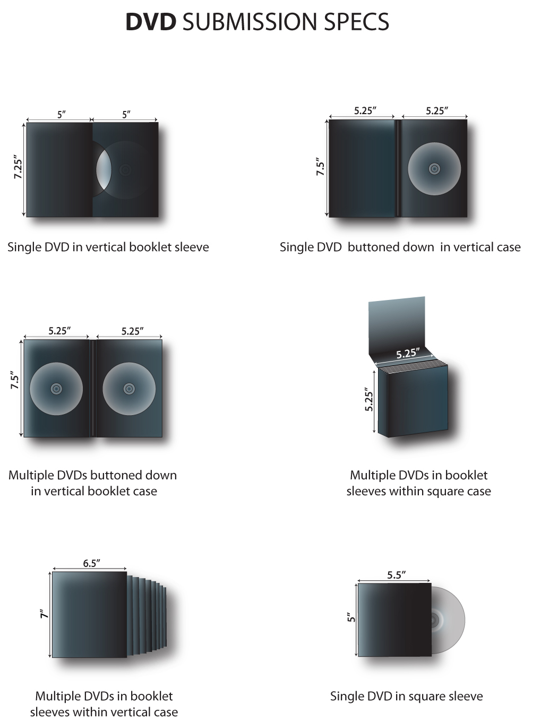
1. What may be sent in the mailings?
DVDs or USB flash-drive/memory sticks.

2. Are there restrictions on the number of programs or episodes sent in a mailing?
No. One or more than one program or episode, as aired in its entirety, may be sent – with the exception of the performer rule below.

OPTIONAL RULE FOR PERFORMER ENTRANTS ONLY: If they wish to, performer entrants may edit their entries down to their appearances only. This is not mandatory, but if this option is chosen, performers must include all their appearances in sequential order from the entire program or from one episode for series performers. (Clips from more than one episode may be included, but additional charges will apply.)

3. What are the requirements of the mailings?
It is not mandatory, but encouraged, to include the phrase “For Your Emmy® Consideration” either on the packaging or prior to the on-screen titles of the program. You may also include the specific category and airdate.

You MAY NOT use the image of the Emmy® statue.

Please note: final categorization is up to the Primetime Awards Committee, so it may be that categorization assumed by the sender will be different from the final categorization made by the Awards Committee. If you are unsure or there are too many entries represented by the program to be reasonably accommodated on the label with a separate designation for each, indicate that the program is for the viewer’s consideration in all (or most) of the eligible categories. It is helpful to include the character’s name for performer entrants.

Anyone sending screeners may contact the Academy's fulfillment house to mutually devise a method for tracking screeners back to the members to whom they were sent. Orders must be placed at least thirty days prior to the mailing date in order to allow the fulfillment house time to prepare the mailing for tracking. Because of the special handling required, the usual handling charges do not apply and they must be mutually worked out by the sender and the fulfillment house. The purpose of this procedure is to allow senders a means to protect their property from piracy and/or sale.

4. Does the Academy charge anything per mailing?
Yes. The Academy charges $150 per program or for a series, each episode, per peer group, with a cap of $1500 per program or for a series, each episode. For example:

1 - 9 peer groups @ $150 per peer group per program or for a series, each episode
10 or more peer groups - flat rate of $1500 per program or for a series, each episode

See the Peer Group Breakdown List on page 5 for a listing of all 28 peer groups.

5. What are the mechanics of the mailing?
- Fill out the order form and send it with payment to the Academy for approval. The contact at the Academy is Sheri Ebner 818-754-2881 or ebner@emmys.org.

- Deliver screeners and payment for shipping and handling to 3R Printing which handles the preparation for mailing and delivery to the post office. The contact at the mailing house is Edgar Stanislavsky 818-841-8000 or edgar@threerprinting.com. Postage and handling fees must be received before your screeners will be mailed.

It is the sender’s responsibility to put either on the packaging or on the screener itself, written notification prohibiting recipients from selling or otherwise transferring possession of the screener in any manner, and the Academy shall have no responsibility for a recipient’s violation of this prohibition.

6. What is the time frame for the balloting?
Nominating ballots will be available June 10. The return deadline is June 28.

7. What is the time frame for mailings?
Screeners may be sent at any time. Mailings will be sent out as soon as possible or within eight (8) days after receipt. The absolute last day to deliver screeners to 3R Printing is June 20. Screeners may not be stored at 3R Printing.
2013 FYC BY MAIL ORDER FORM

Please fill out completely and return (with payment) to the Academy office for approval. E-mail: ebner@emmys.org, mail: Sheri Ebner, Academy of Television Arts & Sciences, 5220 Lankershim Boulevard, North Hollywood, California 91601, fax: 818-754-2836. Questions, call Sheri at 818-754-2881.

Name of company or individual sending screener Contact Person’s Name

_______________________________________________________________________________________________________________________________________
Address

Phone Fax E-mail

____________________________________________________________________________________________________________
Title of Program(s) and Episode(s) if applicable.

_______________________________________________________________________________________________________________________________________
Airdate(s)

Sending to Which Peer Group(s)? If sending to all voting members (28 peer groups), please write ALL.

How Many Screeners Are You Sending to the Mailing House? ___________________________
(See Peer Group Breakdown List on page 4 for the number of members in each group and/or the entire voting membership count)

Approximate Date Your Screeners Will Arrive at the Mailing House? _____________________

ACADEMY PAYMENT INFO. Check for $__________ attached (payable to Academy of Television Arts & Sciences)

American Express, Visa, MasterCard#__________________________________________________________________________

Name on card___________________________________________________________________________

Expiration Date_____________________ 3 or 4 digit code__________________ Amount $____________________

1 - 9 peer groups @ $150 per peer group per program or for a series, each episode
10 or more peer groups - flat rate of $1500 per program or for a series, each episode

MAILING HOUSE PAYMENT INFO.
Handling and posting of screeners will only be done by:
3R Printing, Inc./Edgar A. Stanislavsky, Director of Operations • Telephone # 818-841-8000 • Fax # 818-841-8088
2921 W. Burbank Blvd., Burbank, CA 91505 • E-mail: edgar@threerprinting.com

Postage and handling fees: For one DVD or USB flash-drive, the charge is $4.50 + tax per package (U.S. residents).
For non-U.S. residents – postage rates vary – the mailing house will calculate and notify you of all mailing fees.

If more than one DVD or a boxed set is being sent, additional handling and posting charges will apply. Please call
Edgar at 3R Printing, Inc. for details 818-841-8000.

The undersigned agrees to abide by the policies and procedures as outlined in the attached document, agrees to pay all charges in connection with this shipment, and confirms that the screeners to be shipped comply with the policies established by the attached document.

_______________________________ ________________________
Sender’s Signature Sheri Ebner (for the Academy)

PEER GROUP BREAKDOWN LIST

The number of members cited for each peer group is based on the membership figures for April, 2013, at the time this bulletin was published. It is possible that the numbers will have increased by the time you are ready to send your screeners.

SENDING TO ALL VOTING MEMBERS: 16,000

Numbers vary from day to day – 16,000 is a best estimate to cover 99%-101% of predicted membership at the time the ballots are available in early June, 2013.

Please note: All peer groups receive the Program ballot which now excludes Documentary/Nonfiction programs.

PEER GROUP (# OF VOTING MEMBERS) ADDITIONAL BALLOT(S) RECEIVED**
1. ANIMATION (888) ANIMATION
2. ART DIRECTORS/SET DECORATORS (387) ART DIRECTION
3. CASTING DIRECTORS (252) CASTING, HOST
4. CHILDREN’S PROGRAMMING (259) PROGRAM ONLY
5. CINEMATOGRAPHERS (154) CINEMATOGRAPHY
6. COMMERCIALS (216) COMMERCIALS
7. COSTUME DESIGN & SUPERVISION (211) COSTUME
8. DAYTIME PROGRAMMING (341) HOST
9. DIRECTORS (589) DIRECTING, NONFICTION DIRECTING
10. DOCUMENTARY PROGRAMMING (604) DOCUMENTARY / NONFICTION PROGRAM
NONFICTION INDIVIDUAL ACHIEVEMENTS
11. ELECTRONIC PRODUCTION
-ELECTRONIC CAMERA (121) TD/CAM/VIDEO, LIGHTING
-VIDEOTAPE EDITORS (93) PICTURE EDITING, NONFICTION PICTURE EDITING
-ENGINEERING (18) PROGRAM ONLY
-LIGHTING DIRECTORS (83) TD/CAM/VIDEO, LIGHTING
-TECHNICAL DIRECTORS (43) TD/CAM/VIDEO, LIGHTING
-TECHNICAL OPERATIONS (17) PROGRAM ONLY
-VIDEO CONTROL (42) TD/CAM/VIDEO, LIGHTING
12. INTERACTIVE MEDIA (686) INTERACTIVE PROGRAMMING
13. MAKEUP ARTISTS/HAIRSTYLISTS (454) MAKEUP / HAIR
14. MUSIC (352) MUSIC
15. PERFORMERS (1708) PERFORMERS
16. PICTURE EDITORS (633) PICTURE EDITING, NONFICTION PICTURE EDITING
17. PRODUCERS (1266) HOST
18. PRODUCTION EXECUTIVES (644) HOST
19. PROFESSIONAL REPRESENTATIVES (511) HOST
20. PUBLIC RELATIONS (517) PROGRAM ONLY
21. REALITY PROGRAMMING (575) NONFICTION / REALITY INDIVIDUAL ACHIEVEMENTS
HOST
22. SOUND (378) SOUND MIXING, NONFICTION SOUND MIXING
23. SOUND EDITORS (332) SOUND EDITING, NONFICTION SOUND EDITING
24. SPECIAL VISUAL EFFECTS (283) PROGRAM ONLY
25. STUNTS (233) STUNTS
26. TELEVISION EXECUTIVES (1815) HOST
27. TITLE DESIGN (143) TITLE DESIGN
28. WRITERS (1479) WRITING

